CORPORATE PLAN & PERFORMANCE MONITORING REPORT

Quarter 2 2019-20

Contents | Pg.
Report Structure | 3
Excellence, Investment & Financial Sustainability | 4
Health, Wellbeing And Safety | 9
Place | 16
Our People & Communities | 23

Report Structure
This report forms part of the appendices of ‘Corporate Monitoring Report’ update to the Cabinet for the period Quarter 2 (July – September 2019). Cross references are made within the Cabinet Report to refer to sections containing more detail within this document.
This report reflects the Corporate Plan structure as approved February 2019 and is broken down in to four sections:
- Excellence and Financial Sustainability;
- Health and Wellbeing;
- Place;
- Our People (internal priority).
Within each section is every programme and project that the Council has set out to deliver. Each project and any available performance indicator or measure is reported in this document.
Each project reports on:
- Quarter 2: The activities that have been delivered and progress up until September 2019;
- Going Forward: Any specific activities undertaken since September that provide a relevant update on how performance is being managed/improved where appropriate. It also reflects any changes or impact on the revised Corporate Plan;
- Notable factors with potential to impact success: Any key issues or risks that could impact on the ability to deliver the project that needs to be highlighted to ensure performance is managed.
The development of this document will be an ongoing process over the coming months. This is to ensure that the report is as accessible as possible and provides the right information that the Cabinet, Scrutiny Committee, Members and residents need in order to ensure the Council is performing well.

Corporate Plan (Feb 2019)
The programmes reported in this report relate to the existing Corporate Plan:
- The Council’s Investment Portfolio;
- Transformation;
- New Business Models and Shared Services with Chorley Council.

Going Forward

Excellence, Investment & Financial Sustainability
Excellent services and a strong financial position that enables us to invest in the right way.

As a Council, we want you to feel confident we use the resources available to us to provide the services you told us you need and that we manage our finances well to enable us to invest in communities.

As the Council moves forward, projects and activities that are reported will form part of the Council’s refreshed priorities of:
- We will make effective investment and use of our assets;
- Customers of the Council can expect the highest standards of service and when they need us they have a good experience;
- We will develop new business models and approaches, including shared services.

How Are We Performing?
Below are key performance indicators that demonstrate how well our services are currently meeting their objectives and targets:
% of Council  Tax Collected  57.4%  ON TRACK  Target: 97.5% (annual) | Number of  Complaints Received  23  OFF TRACK  Target: Under 20 | Complaints as a %  of Total Contacts  0.09%  ON TRACK  Target: 2%  Last quarter: 0.15%  This time last year: 0.08% | % of calls answered within 90 seconds  49%  SUCCEEDING  Target: 40%  Last quarter: 20%  This time last year:37%
% of Business Rates Collected  59.0%  ON TRACK  Target: 98% (annual) | % of Complaints  Upheld  22%  OFF TRACK  Target: 20%  Last quarter:13%  This time last year:24% | Number of Compliments Received  16  SUCCEEDING  Target:15  Last quarter: 9  This time last year: 15 | % of calls abandoned before being answered  14%  SUCCEEDING  Target:15%  Last quarter: 38%  This time last year:25%

The Council acts on the feedback it receives from residents. The case studies below illustrate how we respond to complaints and feedback.

Customer Feedback - Case Study
Garden Waste Direct Debits
Background
Upon inception of the Garden Waste subscription fee for 2018/2019 we had 24,241 sign-ups to the service. Of these 24,241 subscriptions there were 15,422 online subscriptions and 8,688 subscriptions via the Gateway contact centre.
One of the frequent complaints and queries we received during this first year was why there was no option for direct debit. We initially advised customers they would need to contact again either online or via phone contact at some point from 2nd January 2019 in order to subscribe to this years’ service
You Said:
“Can I sign up to the Garden Waste Subscription Service using Direct Debit? This means I would not need to ring up to subscribe each year”
We Did:
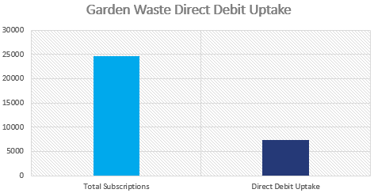
This was an issue that was raised with Neighbourhood Services and IT when feeding back on the success of the first year. Initial meetings established that a direct debit service would be would be necessary to improve the experience of the customer and improve retention rates. The chosen provider was GoCardless.
Conclusion
The implementation of the direct debit service for this year has generated 7,438 sign-ups. Contacts in 2020/2021 should be reduced significantly as a result of the direct debit sign ups this year.
The percentages of sign-ups for the direct debit service in its first year is 30% of total sign-ups. Feedback from customers about a direct debit service indicates a positive effect on customer satisfaction

Customer Feedback - Case Study
Pest Control Visits
Background
Pest Control calls make up the majority of Environmental Health calls that Gateway take. Especially around the summer months a high volume of those calls will be regarding Wasp/Bee treatments. The established process for Wasp/Bee treatments was to take an initial non-refundable site survey payment of £20. Once a Pest Control officer had visited the customer’s address they would then ring up through to Gateway and make a following payment of £22 for the treatment.
However, we had a number of complaints regarding the waiting times that customers experienced as they would come through to the same lines as all other customers therefore experiencing wait times to speak with the next available Gateway officer.
You Said:
“When I call up to pay for my pest control visit I end up waiting in a queue for a long time”

We Did:
Initial response was to develop a system whereby the Pest Control officer would get in contact with Gateway by ringing the main switchboard and we would then hold until a Gateway officer became available and pass through directly – therefore skipping any waiting times.
This still presented problems in that whilst holding for an available agent it would mean other calls to switchboard would back up.
It was later established that a new, more efficient way of working was required. Initial meetings between Gateway, Environmental Health and ICT established that new technology would improve the system dramatically.
Handheld devices and a wireless payment system were developed which the Pest Control officers will be able to use.
Conclusion
Pest Control officers will visit the jobs and use the new technology to establish how much the customer has left to pay and take the transaction without having to liaise further with Gateway. Therefore completely eradicating the long wait times previously complained about.
The feedback from Pest Control officers is that this system is much more efficient, works consistently and provides a more professional service.

The Council’s Investment Portfolio

Percentage Occupancy Rate of the Council’s Current Investment Estate
97%
SUCCEEDING
Target: 95%

Worden Hall  Overall Performance: ON TRACK  Quarter 2: A five week consultation programme with stakeholders and park users to feedback on three identified options for Worden Hall, ended on Monday 16th September 2019. Over 500 people responded to the consultation exercise.  Going Forward: Cabinet received a report and agreed to undertake further detailed modelling and appraisal of Option 1 (Community Use) and Option 2 (small weddings/events venue) with a finalised recommendation and implementation plan back to Cabinet in January 2020.  Notable factors with potential to impact success: As with all consultations, it is essential that expectations are managed with what can be achieved and implications for each model. | Strategic review of Business Case for South Ribble Home Build Proposal  Overall Performance: ON TRACK  Quarter 2: The geo-technical desktop study (preliminary study to evaluate likely ground conditions and any significant geo-environmental issues) has now been completed. We are still awaiting the environmental study which is due imminently.  Going Forward: The business plan and options appraisal has been commissioned and shall be reported to Cabinet in November 2019  Notable factors with potential to impact success: Any adverse ground conditions could render the development inviable.
Phase 2 Business and Conference Centre  Overall Performance ON TRACK  Quarter 2: The Canteen Area plans for design have commenced, looking at the new access area for the Conference and Business Centre and the kitchen. The Second Access/Egress for DWP works was been completed in September 2019. DWP were consulted and instructed on how the doors work.  Going Forward: Discussions are underway regarding the 'staff canteen' and a potential new location within the Civic Centre. Work on the Canteen Area has been agreed to be started in the next financial year. | Strategic asset review of Surplus Sites  Overall Performance ON TRACK  Quarter 2: As there has been staff shortages within the estates team, it has been agreed with the Portfolio Holder for Finance, Property and Assets to defer the Cabinet report to November 2019.  Going Forward: The Cabinet report in November 2019 shall set the strategy and budget for the review to be completed which will then be reported back to Cabinet with recommendations for surplus sites to be considered at the Cabinet meeting in March.

Transformation Programme

% of self-service channel access vs phone/face-to-face
21%
ON TRACK
Target (March 2021): 40%
Baseline (2018/19): 18%
Number of Customer
Journeys Mapped
36
ON TRACK
Target: 50 (Annual)
Number of Service Reviews Carried
Out in Preparation For Customer
Excellence Awards
5
SUCCEEDING
Target: 4

Implement Recommendations from Strategic Digital Review
Overall Performance: ON TRACK
Quarter 2: In this Quarter, the Council has:

- Partnered with Lancashire Adult Learning to deliver an Introduction to Digital training programme, focusing on reducing digital exclusion for those from vulnerable backgrounds;
- There has been significant enhancements to the Council’s Business Continuity and Disaster Recovery capabilities, reducing risk and associated recovery costs to the Council;
- The Council has been re-accredited to the Public Sector Network providing access to digital services from Department of Works and Pensions (DWP), Police and Cabinet Office for another year;
- Wi-Fi upgrades are now complete for the Market, Civic Centre and Depot, providing free superfast internet access for officers, members, visitors and residents;
- An upgraded Microphone and Audio Visual system has been delivered, acting as an enabler for open democracy by providing the foundations for webcasting and audio casting;
- Several Closed Circuit Television (CCTV) cameras have been upgraded to improve resident safety.
Going Forward: ICT Service has been working with Procurement to deliver a Contracts Management System. This has been developed in house using existing resources and is due to go live in October. ICT are testing infrastructure to enable mobile payments by officers, working with Environmental Health Officers to deliver the system. Testing is currently underway for the Cloud based Confrontation Register and testing will begin for the IDOX (product name) Mobile apps for Planning and Planning Enforcement.

Improve customer experience via customer journey mapping
Overall Performance: ON TRACK
Quarter 2: There has been five Customer Service Excellence Self-assessment reviews completed with the following departments: Homelessness, Planning, Revenues, Benefits and Gateway.
Going Forward: There has been initial meetings arranged with Strategic Housing and Environmental Health departments to go through their self-assessments.

Notable factors with potential to impact success: Resourcing is critical to ensure mapping can be completed.

New Business Models Including Shared Services

Shared Services with Chorley Council
Overall Performance: ON TRACK
Quarter 2: Councillors in both Chorley and South Ribble have agreed to extend shared services across both authorities in September 2019. There will be a significant shift in how the authorities are structured providing more resilience, opportunities to improve services and better value for money for residents. The Councils also agreed to progress a review of the Exchequer and Financial Systems team and the Management Accountants team to further improve the shared financial services arrangement
Going Forward: An implementation team will be established and staff consultations will commence in October 2019. The implementation team will manage the implementation of Phase 1 services.

Notable factors with potential to impact success: Frequent communication is ongoing to ensure that relationships remain strong.

Corporate Plan (Feb 2019)
The programmes reported in this report relate to the existing Corporate Plan:
- Green Links, Parks and Campus: Health, Leisure and Wellbeing delivery model focused on prevention and intervention;
- Homelessness and Independent Living Support;
- Lancashire Mental Health Strategy;
- Social Isolation and Loneliness;
- Support for Volunteer and Communities;
- Deliver the Borough’s Air Quality Plan.

Going Forward

Health, Wellbeing and Safety
Residents are happy, healthy and safe, active and independent.
We are focused on doing what we can so that everyone in South Ribble has the choice to access support, advice and activities as well as accessing the right facilities both outdoors and indoors to maintain and improve their physical and mental wellbeing.
As the Council moves forward, projects and activities that are reported will form part of the Council’s refreshed priorities of:
- We have services and facilities in place that are accessible to all, providing the lifestyle for people to feel happy, healthy and confident;
- We continue to be recognised as a Dementia Friendly Community;
- We’re focused on activities that close the gap between communities where there are differences in wealth, health and learning opportunities (reducing social isolation, loneliness and inequality);
- We will actively work with partners across the public, private and 3rd sector, representing the residents of South Ribble so that they receive the best services.

How are we performing?
Below are the key performance indicators that demonstrate how well our services are currently meeting their objectives and targets:

% of Licenced Taxis Inspected  28.57%  ON TRACK  Previous Quarter:10.3%  This time last year: 10.12% | % of Licenced Premises Inspected  18.41%  ON TRACK  Previous Quarter: 17.2%  This time last year: 16.4%
% of Licenced Premises Inspected that have not complied with requirements  18.95%  ON TRACK  Previous Quarter: 34.61%  This time last year: 50.9% | Average Number of Days to Process  a Housing  Benefit Claim  15.2 days  SUCCEEDING  Target: 19 days  Previous Quarter: 17.75 days  This time last year: 24.77 days

Green Links, Parks and Campus: Health, Leisure and Wellbeing Delivery Model Focused on Prevention and Intervention

 | Number of Visits to  Leisure Facilities  207,112  SUCCEEDING  Last quarter: 195,687  Same time last year: 199,147 | Number of km completed  of the Green Links  2.5 km  ON TRACK  Target: 7km (annual)
 | Signage and legibility  Improvements made across the Green Links  7km  ON TRACK  Target: 17km (annual) | Number of Improvements  made to Access Points on the Green Links  5  ON TRACK  Target: 7 (annual)
Number of South Ribble residents
taking part in Digital Training Sessions
run by Lancashire Adult Learning
13
ON TRACK
Target: 280 (annual)
Note: The low figure for quarter 2 was expected as the course only operates during the academic year.
Commence Next Phase of Borough Green Links
Overall Performance: ON TRACK
Quarter 2: Within the Quarter, 2.5km of paths as part of the Green Links programme has been completed. 7km of signage and legibility is complete. Improvement works on 5 entrances to access points on the green links is complete.

Going Forward: Contracts have been let for 4km which will be delivered in the next Quarter and an additional 1 km will be delivered by Lancashire County Council Carrwood Road Scheme,

Develop Masterplan for Leyland Health Leisure and Wellbeing Site
Overall Performance ON TRACK
Quarter 2: Following a change in administration this project has been re-scoped, with a report going to Cabinet and Full Council. The report provided a full breakdown of costs, timescales, funding options, and recommendations on what can be achieved. A decision has been made to stand back from the current project, due to its cost and look at identifying a more sustainable way forward.

Going Forward: The Council will work with identified partners to develop a sustainable option for a viable new Leisure Centre in South Ribble. A sustainable investment plan for our existing Leisure Centres will be developed to ensure they are fit for purpose over the next 5 years. The aim will be to bring a sustainable option forward to Cabinet and Full Council before April 2020,

Scope Options for Leisure Delivery, Identify Preferred Option and Commence Delivery
Overall Performance: ON TRACK
Quarter 2: A project team has been put together with staff from Legal, Procurement, Finance and Leisure. A consultant has been appointed from FMG to look at future management of the leisure sites along with an extension with the current management (Serco). Meetings are currently being held with regarding the extension and this will included potential cost saving options.

Green Links, Parks and Campus: Health, Leisure and Wellbeing Delivery Model Focused on Prevention and Intervention (cont.)

Continue Delivery of Major Parks Masterplan
Overall Performance: ON TRACK
Quarter 2: Work has been ordered for the replacement of log edgings at Worden and Farrington Park playgrounds. Tenders have been drafted and released for Worden, Leadale and Seven Stars playground refurbishments. The tender returns are due in November 2019 and a start on site planned for the New Year.

Going Forward: Tender Documents for Hurst Grange Park Coach House are currently being drafted (award subject to a successful lottery bid).The lottery bid is being finalised for submission at the beginning of November. Future projects are the design and tendering of works to Worden Park overflow car park and improvement works at Tarn Wood, Penwortham.

Notable factors with potential to impact success: Hurst Grange Park will be subject to competition on the outcome of the decision by the Heritage Lottery.

Commence work identified in Open Space Sports and Recreation Assessment and Playing Pitch Strategy
Overall Performance ON TRACK

Quarter 2: Initial meetings have been held with consultants from Knight, Kavanagh and Page (KPP) and Lancashire Football Association. KKP have provided an outline proposal to support the feasibility of developing a new football hub site in South Ribble. The Council has identified 3 locations for the hub, with one being the preferred site
The Council has set requirements of two 3G (Third Generation) football pitches, car park, changing facilities and a possibility of a Netball/Futsal indoor area and small fitness suite.

Going Forward: A meeting will be held in November 2019 where KKP will have adapted the proposal to include cost plan/mock up and simple business plan.

Preventative and Educational Digital Health and Wellbeing Programme
Overall Performance: ON TRACK

Quarter 2: The project is progressing well with the following activities delivered within the quarter

- A full year’s programme of Digital Skills training has now been arranged with Lancashire Adult Learning. Courses up to January 2020 are now being promoted with partners and over social media;
- Refernet has now been signed off by the Portfolio Holder and is due to go live in October 2019;
- Accessibility requirements for the Council website have been built into the technical specification currently being put together by Chorley and South Ribble Councils;
- Integration has been built with the National Charge point Registry to provide up to date EV charge station locations to South Ribble residents and promote the use of electric vehicles.

Going Forward: A clear set of deliverables have been agreed with the new administration and this project will go forward in the revised Corporate Plan.

Homelessness and Independent
Living Support
Implement a New Service Delivery Model of Health Focused on Prevention
Overall Performance: ON TRACK
Quarter 1: Revisited procedures with local prisons for referrals under duty to refer, completed a funding bid through Rapid Rehousing Pathway for rough sleepers, and reviewed and re-commissioned services for Sanctuary, Young Peoples Housing Advice, and Enhanced Floating Support.

Number of Homeless  Presentations  246  ON TRACK  Previous Quarter: 205  Same time last year: 210 | Number of households relieved from being homeless  17  ON TRACK  Previous Quarter:18
Number of people who are homeless and which we have full duty under the Act  12 new  ON TRACK  Previous Quarter: 13  (9 new) | % of households  that had homelessness  prevented  84.68%  (94 of 111)  ON TRACK  Previous Quarter:  78.31% (65 of 83)

Number of families  in B&B  0  SUCCEEDING  Previous Quarter: 3 | Numbers in temporary  accommodation  25  ON TRACK  Previous Quarter: 32
Total number of new  Rough Sleepers  3  ON TRACK  Previous Quarter: 3 | Average number of days from Disabled Facilities Grant (DFG) referral from LCC to application  142  OFF Track  Previous Quarter: 94  Same time last year: 131

Social Isolation and Loneliness

Number of additional
local businesses signed up
to the Dementia Charter (Cumulative figure)
5
ON TRACK
Target: 15 (annual)

Continue to Deliver the Key Actions of the South Ribble Dementia Action Alliance
Overall Performance: ON TRACK
Quarter 2: Significant progress has been made throughout Quarter 2, more specifically this has included:

- A full alliance meeting taking place where there were presentations from Dr Penny Foulds on dementia research, NatWest on avoiding scams, and Happy Days Dementia Workshops on using nostalgic activities and design;
- 111 Avacab taxi drivers becoming Dementia Friends and Avacab joined the Dementia Charter;
- Living Well Walk event management plan completed ready for the event to take place on 5th October at Longton Brickcroft. An updated Living Well Guide will be handed out at the Living Well Walk;
- British Commercial Vehicle Museum joined the Dementia Charter as a result of the High Street Blitz.
Going Forward: Final plans have been approved for the Dementia Friendly garden at the Civic Centre with work set to commence soon. Work has also been underway to plan to develop a Dementia Friendly garden on Bent Lane, this has involved consultation with residents.
Notable factors with potential to impact success: The high street blitz has progressed slowly throughout this Quarter with only one additional member of the charter being achieved. There will be a push for more volunteers next Quarter along with a campaign to encourage more organisations to join the charter and individuals to become Dementia Friends.

Support for Volunteers and Communities
Review the Council Tax Support Scheme for 2020/2021
Overall Performance ON TRACK
Quarter 2: Approval was given at Cabinet on 10th July 2019 to undertake a consultation exercise. Consultation with preceptors and residents has now taken place and closed on 27th September 2019.
Going Forward: The results have been collated and analysed and is due to go to Cabinet on 13th November 2019. The outcome of the consultation exercise is currently being prepared and is due to go to Council on the 27th November to approve the scheme for 2020/21. Enquiries are being made with our software supplier regarding system set up for the proposed changes to the scheme
Work With Partners to Deliver Actions Identified in the Volunteering Strategy
Overall Performance: ON TRACK
Quarter 2: A new scope for the Project has been established in consultation with the portfolio holder and the senior responsible officer. The re-scoped project will be focused on:
- Standardising existing practises across the Council;
- Celebrating and recognising those who volunteer for the Council;
- Providing more opportunities for people to Volunteer with the Council, either on a regular basis or ad hoc;
- Policy for Employees and Volunteering.

Going Forward: Meetings have been set up with a number of existing volunteers and officers to consider platforms and processes on how we can support co-ordination and management of volunteers across the Council. The Council has sponsored the Community Awards and is the recognised organisation as sponsor for 'Volunteer of the Year'. The awards are to be hosted at the Civic Centre in January 24th 2020. Time Credits continues to progress with an application for funding to a local partner having been submitted and a response due shortly. On success of the award the proposal can continue with an anticipated start date of January 2020.

Deliver the Borough’s Air Quality Plan
Delivery of Actions Identified in the Air Quality Action Plan
Overall Performance ON TRACK
Quarter 2: We are progressing a number of Actions identified in the Air Quality Action Plan.
- Work has begun on the new changing facilities at the Civic Centre;
- Salary sacrifice scheme progressing for electric vehicles.
- Two of the three road improvements are near completion.
- A new Air Quality and Climate Change post has been agreed and will be recruited over the next quarter.
- A members learning hours was held on Air Quality.
- The anti-idling campaign is progressing with information and education taking place in all schools.
- Representations have been made on the Central Lancashire Core Strategy about Air Quality.

Going Forward: The on-site educational element of the anti-idling campaign will take place. A meeting has also been arranged with LCC to progress a number of actions which include traffic light sequencing and signage. The planning advisory note on Air Quality will be drafted and work will take place on a Supplementary Planning document on Air Quality. Progress work on the feasibility of a link road on Tomlinson Road. A study will be undertaken to lay the framework on additional Air Quality monitoring in Penwortham and Lostock Hall.

Notable factors with potential to impact success: This project is dependent on our partnership with LCC and therefore subject to their timeframes and their ability to commit resources to this project.

Lancashire Mental Health Strategy
Deliver Actions Identified from the MH2K Project
Overall Performance ON TRACK
Quarter 2: The initial task to re-establish an advisory panel of organisations has been completed and a reshaped action plan agreed. This has broken down a number of actions in to manageable activities which will be addressed by the panel. In the Quarter a brief was developed with support from Chorley and South Ribble Clinical Commissioning Group for a LGBT video resource, to be produced by students at Runshaw college.
Going Forward: Development and production of the video is scheduled for between November 2019 and February 2020. The project has also undergone a refresh of its scope to outline the video development, its release and promotion.

Notable factors with potential to impact success: This project is a partnership between organisations and is therefore subject to external pressures beyond the Council’s control, but strategies for mitigation are in place.

Corporate Plan (Feb 2019)
The programmes reported in this report relate to the existing Corporate Plan:
- City Deal and Plan for Successor;
- Central Lancashire Local Plan;
- Cuerden Strategic Site;
- Economic Strategy: Support for existing as well as new businesses;
- River Ribble Master planning;
- Housing Framework: delivery of a balanced housing market;
- Place Promotion;
- Raising community aspirations in relation to growth and improvements in the Borough;
- My Neighbourhood Plans.

Going Forward
Place, Homes and Environment
Our green spaces are valued and development is well managed.

We are focused on ensuring South Ribble remains a great place to live and work by protecting green and open spaces, safeguarding our environment, increasing the number of affordable housing and ensuring that development is managed.

As the Council moves forward projects and activities that are reported will form part of the Councils refreshed priorities of:
- We are focused on the environment, improving the air we breathe and having the right plans in place to safeguard and protect our natural environment;
- We will promote safe, secure dwellings that people can afford to live in and can call home;
  - We will make sure that development in South Ribble is managed, so that we have a vibrant community; delivering improvements to our town centres, opening opportunities for people to get the jobs they want and supporting businesses to do well;
  - We will continue to develop our wonderful parks, attracting investment to provide better facilities so that as many people as possible are able to enjoy them.

How are we performing?
Below are the key performance indicators that demonstrate how well our services are currently meeting their objectives and targets:
Number of Pre-Applications  Received  60  ON TRACK  This time last year: 54 | % of Minor and Other Applications Decided in 8 Weeks  94.52%  ON TRACK  Last quarter: 93.48%  This time last year: 93.28%
% of Major applications decided in 13 weeks or within Extension of time agreed
100%
SUCCEEDING
Last quarter: 77.78%
This time last year: 85.71%

City Deal and Plan for Successor Programmes

Act as an Enabling Authority Whilst Working with Partners and Developers to Increase the Rate of Delivery of New Homes and Commercial Floor Space by Unlocking City Deal Sites, and Prioritising Infrastructure Development.
Overall Performance ON TRACK
Quarter 2: The half year housing completions are on target, this includes 55 affordable homes. It was also noted on site visits that there were a significant amount of activity on development sites with many other homes close to completion.

Notable factors with potential to impact success: The progress of this project is heavily reliant on progress also being made by partners.

Number of New  Homes Delivered  255 | Number of New Affordable  Homes Delivered  55
Note: Housebuilding data is presented cumulatively as this is only measure at Q2 and Q4

Carry out a strategic review of projects listed in the City Deal Business and Delivery Plan 2017-20, Identify Priorities and Commence Delivery.
Overall Performance OFF TRACK
Quarter 2: The City Deal Review is ongoing and a piece of work has been undertaken to prioritise projects. This work has not however been approved by the City Deal Executive given the ongoing discussions regarding City Deal.
Going Forward: Once the wider City Deal agreement is in place then the prioritization work will be considered by the City Deal Executive.

Notable factors with potential to impact success: City Deal projects continue to progress slowly, all being heavily reliant on partnership working.

Scope and Prepare Masterplans for Key Centres in South Ribble, Including Consultation with Local Residents and Businesses, and Commence Delivery.
Overall Performance: ON TRACK
Quarter 2: Leyland Town Centre Masterplan – we are progressing through consultation to final draft. Meetings between the Director of Planning and Property and consultants has been arranged to agree the next steps.

Penwortham Centre Masterplan – we are currently waiting for Lancashire County Council (LCC) to finalise their engineering proposals for Liverpool Road (post by-pass) before we commence our plans.

Bamber Bridge Masterplan – this activity needs a steer from Members, a decision needs to be made for this Masterplan given some work has recently been done to Bamber Bridge Town Centre.

Notable factors with potential to impact success: The progress and success of this project is reliant on other parties. Frequent communication is carried out to maintain mutual strategic direction, and consultation is to be carried out with local businesses.

Central Lancashire Local Plan
Prepare and Consult on Issues and Options for the Central Lancashire Local Plan and Prepare Draft.
Overall Performance: ON TRACK
Quarter 2: In this Quarter, we are currently seeking consent from the respective Councils to go out to consultation with the ‘Issues and Options’ consultation.

Going Forward: This will be a significant consultation with the general public, statutory undertakers and other interested parties as to the issues that the Local Plan should be considering and what options should be taken forward. This consultation will run from 15th November until 14th February 2020

Notable factors with potential to impact success: There is potential that there is a lack of engagement with the consultation. The consultation will be as wide as possible and use new ways of reaching groups that possibly don’t fully engage, such as young people.

Cuerden Strategic Site
Implement Phase 2 of the Employment and Skills Plan
Overall Performance: ON TRACK
Quarter 2: Lancashire County Council (LCC) have announced in the summer that their Cabinet has given the go-ahead to progress the Cuerden site. LCC are now in the process of selecting a development partner for the site. A revised planning application will be needed for the scheme due to the changing nature of the proposals. However, no application has been submitted yet. Work is continuing to make sure that development partners are aware of the need for Employment and Skills Plans, as are LCC. A set of Employment, Skills and Socio Economic Value (ESSEV) benchmarks has been established specifically for the Cuerden site, based on best practice. The ESSEV document has been shared with Members and is awaiting sign-off for publication. The new development partners will be engaged on Apprentice Factory support as soon as they are announced. It has been agreed that this project will encompass the implementation of employment and skills plans on all the development sites in South Ribble, which meet the size criteria.

Notable factors with potential to impact success: The progress of this project is reliant on LCC driving the project forward, identifying a development partner and securing occupiers for the site.

Economic Strategy: Support for Existing As Well As New Businesses
Prepare and Implement a Central Lancashire
Economic Strategy and Align to City Deal (including supporting new and small businesses)
Overall Performance: ON TRACK
Quarter 2: The consultants have produced separate draft economic frameworks for South Ribble, Preston and Chorley.
Going Forward: The frameworks need to align with the emerging pillars of the Lancashire Industrial Strategy (LIS) and to inform the refresh of the Strategic Economic Plan (SEP) for Lancashire. The timescales need to align with the new central Lancashire Local Planning Framework as the strategy will inform the Local Plan and will sit alongside an updated Employment Land and Premises Study to form the evidence base. The emerging issues and priorities have been shared with Members and are awaiting their input. The project is on track to meet the Local Plan timescales, which will be after the 2020 local elections.

Notable factors with potential to impact success: Progress of this project is dependent on partnership working and external influences.
Number of High Level Jobs  in the Borough  TO BE REPORTED  QUARTER 3 | Number of Large, Medium, Small and Micro Businesses in the Borough  TO BE REPORTED  QUARTER 3

River Ribble Master Planning
Prepare Masterplan for River Ribble Green Links Including Consultation and Implementing Priority Projects.
Overall Performance: ON TRACK
Quarter 2: Work has been undertaken to develop a brief that is subject to approval by Members. This work will be intrinsically linked to the Environmental Agency flood defence work which will deliver a large percentage of our intended outcomes.

Going Forward: This activity will be taken forward as part of the revised Corporate Plan. The masterplan is to be developed in-house, with the initial draft ready for consultation in Quarter 4.

Notable factors with potential to impact success: The success of this project is reliant on external partners and decisions.

Housing Framework: Delivery of a Balanced Housing Market
Deliver Actions Identified in the Private sector Stock Condition Survey.
Overall Performance: ON TRACK
Quarter 2: The review of both stock condition surveys has now been completed, the data is now being analysed and actions to be delivered will by produced as scheduled in the project.

Going Forward: There has been an issue with the data in the 2019 stock condition survey not in the same format as the previous survey in 2012 however, this has now been resolved with BRE (Building Research Establishment).

Notable factors with potential to impact success: The success of the project will depend on 2 factors, these are:
- Recommendations being approved by Council;
- Funding to implement findings of the survey.

Percentage of Total Housing  Stock that are Empty  (for six months or over)  1.38%  ON TRACK  Previous Quarter: 1.27%  Same time last year: 1.40% | Number of Empty Properties within the Total Housing Stock  (for six months or over)  690  ON TRACK  Previous Quarter: 633  Same time last year: 695

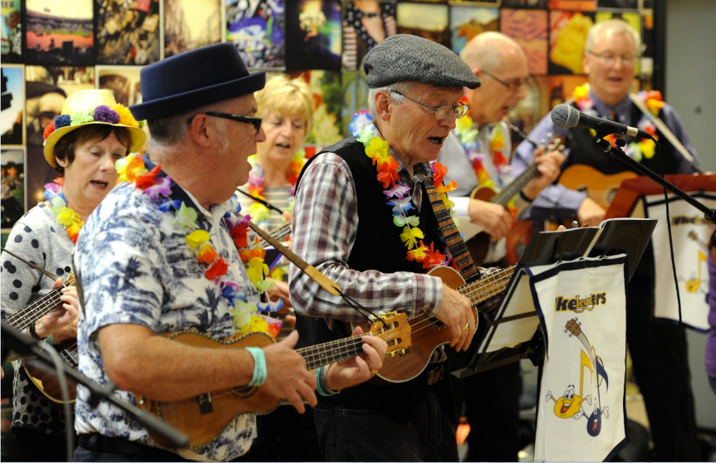
Place Promotion
Develop South Ribble Programme for Festivals and Events, to Build on South Ribble’s Thriving Community Spirit.
Overall Performance: ON TRACK
Quarter 2: Within the quarter the events programme for 2019-20 has continued to be delivered. The events that where held during quarter 2 include:
- Longton Village Market and Welcome Café;
- Lostock Hall dementia friendly Bob-In café;
- Taste of Leyland Food Festival;
- Longton Live.

Going Forward: The revised Corporate Plan seeks to develop a music festival/event to be hosted within the borough as part of developing its festivals and events programme.

Notable factors with potential to impact success: A change in scope is being looked at with work ongoing to explore new models for organising and running events which may increase the resource requirements to meet demand of type and size of events. Due to the current incentive structure in place for working events on the weekend, there are a limited number of volunteers available.

My Neighbourhood Plans
Deliver Projects Within the Agreed My Neighbourhood Plans.
Overall Performance: ON TRACK
Quarter 2: Projects contained in My Neighbourhood Plans continued to be delivered, the outcomes for Quarter 2 include:

- Successful 'In Bloom' competitions for Leyland, Penwortham, Western Parishes, Lostock Hall and Farington;
- Popular events held such as Leyland Festival, Longton Live, Taste of Leyland;
- There has been work ongoing to promote dementia awareness and reduce social isolation;
- A holiday hunger scheme to support vulnerable families.

Going Forward: A review of the My Neighbourhoods approach is being undertaken and a Cross Party Working Group has been established to identify recommendations on how it can be developed.

Notable factors with potential to impact success: The delivery of projects is not expected to be impacted within the current year. However, the review of My Neighbourhoods is ongoing and there may be unknown impacts.
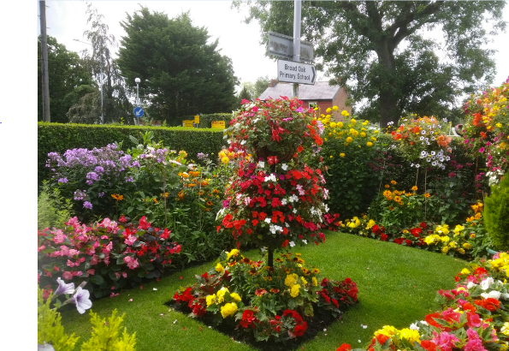
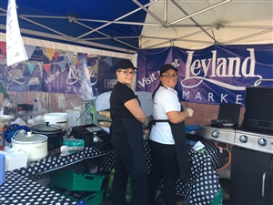

Raising Community Aspirations in Relation to Growth and Improvements in the Borough
In Collaboration with Partners, Deliver Actions Identified Within the Strategy.
Overall Performance: ON TRACK
Quarter 2: The Partnership's Leaders and Executive Boards have identified 3 key areas of focus to define the action plan for the Partnership over the next 12 months. These strands are:  Strand 1, Referrals and Pathways  Part A: Education, Skills, Aspirations (Growth):  - Develop initial skills/confidence;  - Preparedness for work;  - Developing aspirations;  - Advancing social mobility.  Part B: Health (Place):  - Early Action and Intervention;  - Integrated services;  - Community based approaches to self-care/management and prevention.  Strand 2, Connected Communities  Developing Volunteering (Connected):  - Recruitment (including skilled volunteering);  - Incentivised Volunteering / Engagement. | Strand 3, Communication and Culture  Part A: Internal Communications:  - Improve communication across the Partnership in the form of a Communication Strategy. How we can communicate more effectively as a Partnership.  Part B:External Communications:  - Wider communication in terms of organisations understanding what different services/opportunities are being delivered. Elements of this included reference to Refernet which provides a digital platform which details different services available to residents/service users.  Going Forward:  Meetings have been set up with key stakeholders and partners at an operational level to define activities and agree actions to take forward. These will then form part of the action plan that can be monitored and evaluated.

South Ribble Partnership - Big Do 2019
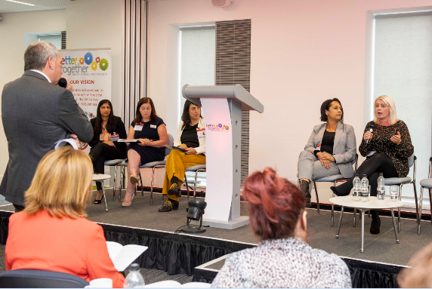
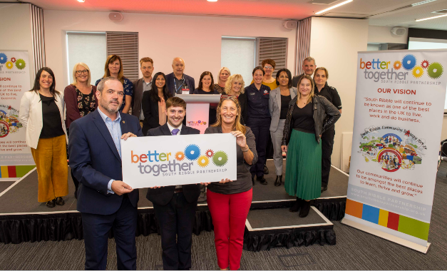

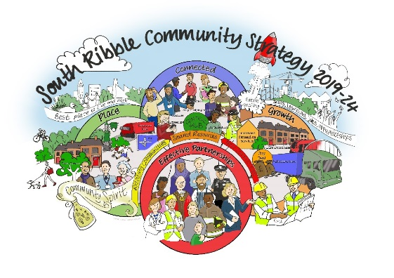
The Big Do Event took place in September 2019 at BAE Academy of Skills and Knowledge. The event was a great success, gathering all the Partnership’s members and wider stakeholders including key note speaker Maria Desmond, MBE and the MC for the day, Dave Guest from BBC North West Tonight.
The purpose of the event was to:
- Launch the South Ribble Community Strategy 2019 -2024.The Community Strategy sets out a shared vision for South Ribble between communities, service providers and businesses;

- Set out areas of its work programme and encourage participation and collaboration.

Corporate Plan (Feb 2019)
The programmes reported in this report relate to the existing Corporate Plan:
- Organisational Development;
- Apprentices.

Going Forward

Our People and Communities
Strong and active communities where people are engaged and have a voice.
South Ribble has an amazing sense of community. We want to support communities to be able to shape what we do as a Council, as well as us supporting communities to take part in active democracy, decision making and leading activities within their communities that they want to provide.
As the Council moves forward projects and activities that are reported will form part of the Council’s refreshed priorities of:
- We invest in the people who work, volunteer and actively get involved with the Council, developing their skills, voice and confidence;
- Communities are able to get involved, have a voice and feel supported to make things happen in their community;
- The Council seeks innovative ways to ease the financial burden on residents.

How are we performing?
Below are the key performance indicators that demonstrate how well our services are currently meeting their objectives and targets.

Average Number of Lost  Days to Sickness  per FTE  2.28 days  ON TRACK  Target: 2 days  This time last year: 2.17days | Average Number of Lost Days to Short-Term Sickness per FTE  0.72 days  ON TRACK  This time last year: 0.62 days | Average Number of Lost  Days to Long-Term  Sickness per FTE  1.57 days  ON TRACK  This time last year: 1.54 days
Number of Staff  Leaving Involuntarily  0  SUCCEEDING  Dec 2018: 1  This time last year: 4 | Number of Staff  Leaving Voluntarily  7  ON TRACK  Dec 2018: 5  This time last year: 14 | Number of Lost Days due to Accidents  29 days  OFF TRACK  No Target  Previous period : 2 days | Number of Days Lost due to Work Related Stress  0.18 days  No Target  Previous period:  0.5 days

Organisational Development
Bring Forward a Comprehensive Member Development Programme
Overall Performance: ON TRACK
Quarter 2: The Member Development Steering Group has held its first meeting, received a presentation from the North West Employers’ Organisation on the North West Member Development Charter and is starting to develop a strategy to achieve level 1 of the charter.

Going Forward: In addition to the Member Development Steering Group, a comprehensive Member development programme is in place and an evaluation of the Member induction process planned.

Notable factors with potential to impact success:
It is important that our approach to developing Members is Member led and tailored to their individual needs. Engagement with all Members will therefore be the key to success.

Apprentices
Apprentice Factory Phase 2
Overall Performance: ON TRACK
Quarter 2: The Class of 2019 have now started their Apprenticeships at South Ribble Borough Council. After exceeding government targets for the number of Apprenticeships in 2017, the Council continues to support the scheme with the introduction of the new cohort of six apprentices in 2019. The team of new apprentices have joined the Communications, Investment and Skills, Partnerships, Environmental Health and Building Control teams. The qualifications that the Apprentices will study for include Digital Marketing, Business Administration, Regulatory Compliance and Construction and the Built Environment.
Going Forward: The council will work in partnership with Runshaw College and Preston's College to deliver training courses and qualifications.

Notable factors with potential to impact success: An element of the project originally scoped for the Apprentice Factory Hub to be located within the Civic Café however, the renovation within the Civic Centre has not progressed in this area as planned and therefore additional time has had to be taken to explore other options.

Number of Staff Undertaking Apprenticeships  at the Council  TO BE REPORTED  QUARTER 3 | % of Council Staff undertaking Apprenticeship Qualifications  Target: 2.3% (National Public Sector Target)  TO BE REPORTED  QUARTER 3

